### Making an export

When you import a sensorlist NavVision automatically generates the “_generated”fields. There can be a time that you need to have one of these generated files without an import upfront. This can be done by stating NavVision with the extension “EXPORT”.

Find the file “NavVision.exe” in the folder NavVision/bin/ and right click on it. Choose create a shortcut. Right click on that shortcut and choose “properties”. In the target window type EXPORT in capitals at the end of the line (see ).

Choose OK and start NavVision up by doubleclick on the shortcut. When NavVision has started you can close it directly. NavVision will have generated the files. Now you can go further as planned.

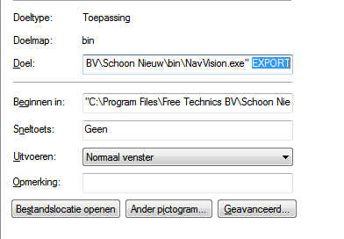

Figure 12‑11: Export shortcut